**A PROJECT REPORT**

**ON**

Meetup Platform

**SUBMITTED TO THE SAVITRIBAI PHULE PUNE UNIVERSITY, PUNE**

**IN THE PARTIAL FULFILLMENT FOR THE AWARD OF THE DEGREE**

**OF**

**BACHELOR OF BUSINESS ADMINISTRATION**

**IN**

**COMPUTER APPLICATION**

**BY**

Vijay Sunil Gholve 5829

**UNDER THE GUIDANCE OF**

Prof. Watpade A.S.

****

**Year 2025-26**

**  **

***Rayat Shikshan Sanstha's***

**S. M. JOSHI COLLEGE, PUNE**

**HADAPSAR, PUNE 411028**

**DEPARTMENT OF COMPUTER SCIENCE AND APPLICATION**

**2025-26**

**CERTIFICATE**

This is to certify that the project report entitled

Meetup Platform

**-----Submitted by**

Vijay Sunil Gholve 5829

is a bonafide work carried out by them under the supervision of **Prof. Watpade A.S.** and it is approved for the partial fulfillment of the requirement of Savitribai Phule Pune University for the award of the Degree of **Bachelor of Business Administration in (Computer Application)**

This project report has not been earlier submitted to any other Institute or University for the award of any degree or diploma.

**Prof. Watpade A.S. Hon. Sangeeta Yadav**

Project Guide Head of Department

Department of Computer Application

**Dr. S. T. Salunkhe**

**External Examiner** **Principal**

S. M. Joshi College Hadapsar, Pune

**Place:**

**Date:**

**ACKNOWLEDGEMENT**

We feel great pleasure in expressing our deepest sense of gratitude and sincere thanks to our guide **Prof. Watpade A.S.** for their valuable guidance during the Project work, without which it would have been a difficult task. I have no words to express my sincere thanks for valuable guidance, extreme assistance and cooperation extended to all the Staff Members of our department.

This acknowledgement would be incomplete without expressing our special thanks to **Hon. Sangeeta Yadav,** Head of the Computer Application department for her support during the work.

We would also like to extend our heartfelt gratitude to our Principal, **Dr. S. T. Salunkhe** who provided a lot of valuable support, mostly being behind the veils of college bureaucracy.

Last but not the least we would like to thank all the Teaching, Non-teaching staff members of our Department, our Parents and our colleagues those who helped us directly or indirectly for completion of this project successfully.

Vijay Sunil Gholve 5829

**Index**

CHAPTER TITLE PAGE NO.

1 INTRODUCTION 1

2 SYSTEM ANALYSIS 3

3 SYSTEM DESIGN

5 OUTPUT AND REPORTS TESTING

6 CONCLUSION & RECOMMENDATIONS

7 FUTURE SCOPE

8 Bibliography and REFERENCES

**Introduction**

#### **Motivation**

In an increasingly digital and interconnected world, the significance of genuine local connections and shared experiences remains paramount for both community well-being and personal development. However, individuals often face substantial challenges in discovering local groups aligned with their specific interests, organizing events efficiently, and managing attendee participation. The current landscape of social platforms often results in a fragmented experience, with users relying on disparate tools or being geographically limited in their search for like-minded communities. The motivation for developing ConnectLocal stems from this recognized need for a unified, integrated, and user-friendly platform that empowers individuals to forge meaningful local connections and collectively pursue their shared passions.

#### **Problem Statement**

The existing landscape for local community engagement and event organization is characterized by several significant challenges that hinder effective interaction. First, a **discovery fragmentation** problem exists where users struggle to find groups that align with their niche interests, as relevant information is scattered across various social media platforms and unorganized websites. Second, **organizational inefficiency** plagues group leaders who must manually manage member lists, schedule events, and disseminate updates using disparate and unintegrated tools. Finally, there is a pervasive issue of **limited engagement tools**, as many platforms lack robust features for fostering ongoing communication, discussion, and feedback within groups, which ultimately undermines community cohesion. ConnectLocal seeks to directly address these issues by providing a dedicated and centralized solution.

#### **Purpose/Objective and Goals**

The overarching **purpose** of the ConnectLocal project is to develop a comprehensive and intuitive web platform that simplifies the entire lifecycle of creating, joining, and managing local community groups and events. This will foster stronger social bonds and facilitate shared experiences. Our **primary objectives** are:

Our **goals** are to achieve these objectives through the implementation of core functionalities such as user management, group and event creation tools, integrated messaging, and a robust search engine, all while prioritizing a scalable and secure architecture.

#### **Literature Survey**

A comprehensive review of existing literature was conducted to understand the current landscape of event management systems, including a meticulous examination of platforms such as Meetup.com, Eventbrite, and Facebook Events. This survey provided a clear understanding of the strengths and limitations of these solutions. Key areas of investigation included emerging technologies like AI for personalization, real-time communication protocols, and secure digital payment solutions. The survey also informed the selection of the most suitable technological frameworks and established best practices for user experience, security, and scalability. This foundational research ensures that the project is strategically positioned to address existing market gaps with a forward-thinking and robust solution.

#### **Project Scope and Limitations**

The **scope** of ConnectLocal is defined as a full-stack web application covering user management, group and event management, communication, discovery, and basic analytics. The system will be designed to be fully responsive for use across all devices. The project's **limitations** include not implementing advanced monetization features beyond a primary payment gateway, a lack of built-in live streaming capabilities, and a focus on a single language for initial development. These advanced features will be considered for future iterations of the platform.

**System Analysis**

* Meetup.com: A long-standing platform specifically designed for local groups and events based on shared interests.
* Facebook Groups/Events: A widely used social media feature that allows users to create private or public groups and
* organize events.
* Eventbrite: Primarily a ticketing and event management platform, often used for larger, public events.
* Local Community Forums/Websites: Various smaller, often niche-specific, online forums or websites catering to
* particular local interests.

**Project, Perspective, Features**

* Unified Ecosystem A single platform for group discovery, event organization,

communication, and analytics.

* User-Centric Design Prioritizing intuitive navigation and a clean, modern interface for all user roles.
* Robust Group Management Empowering organizers with fine-grained control over their groups and events.
* Enhanced Discovery Intelligent search and filtering to connect users with highly relevant communities.
* Real-time Engagement Integrated chat, discussion forums, and notifications for dynamic interaction.

**Stakeholders**

* Primary Users:
  + Group Organizers: Individuals or entities responsible for creating and managing groups and events.
  + Group Members/Event Attendees: Individuals who join groups and participate in events.
  + Platform Administrators: The team responsible for maintaining the platform, user support, and overall

system health.

* Secondary Stakeholders:
  + Local Businesses/Venues: Who might host events or

offer services to groups.

* + Community Organizations: Non-profits or associations

looking to expand their reach and engagement.

**Functional Remuements**

* User Management: User registration, login/logout, profile creation/editing, password management (reset, change),
* account deactivation.
* Group Management: Create/edit/delete groups, join/leave groups, set group privacy (public/private), manage group
* members (add, remove, assign roles), group discussion forums.
* Event Management: Create/edit/delete events, set event details (date, time, location, description), RSVP functionality
* (attend, decline, maybe), attendee list management, event reminders/notifications.
* Discovery & Search: Search groups by name/interest/location, search events by date/category/location, filter search
* results.
* Communication: In-app messaging between group members, group-wide announcements, event-specific chat.
* Notifications: Real-time notifications for new events, messages, RSVPs, and group updates.
* Reporting & Analytics: Dashboard for organizers to view group member count, event attendance rates, and basic
* engagement metrics.

**Performance Remuements**

* **Response Time:** User interface actions (e.g., loading group pages, submitting RSVPs) should resp Read-Onlyond within 2-3 seconds

under normal load.

* **Scalability:** The system must support concurrent users (e.g., 10,000 active users) and manage a growing number of
* groups and events (e.g., 50,000 groups, 100,000 events) without significant performance degradation.
* **Availability:** The platform should maintain 99.9% uptime, excluding scheduled maintenance.
* **Load Handling:** The system should gracefully handle peak loads during popular event announcements or registration periods.

**Security Requirements**

* Authentication: Secure user authentication using industry-standard protocols (e.g., JWT, OAuth2).
* Authorization: Robust role-based access control (RBAC) to ensure users only access authorized functionalities and data.
* Data Encryption: All sensitive data (e.g., passwords, personal information) must be encrypted both in transit (SSL/TLS)

and at rest (database encryption).

* Input Validation: Comprehensive input validation to prevent common web vulnerabilities (e.g., SQL injection, XSS).
* Privacy Compliance: Adherence to relevant data privacy regulations (e.g., GDPR, CCPA) for user data handling and consent.
* Audit Trails: Logging of critical system actions for security monitoring and incident response.

**System Design**

* Design Constraints
* Budget: Development and operational costs must remain within a defined budget.
* Timeline: Project completion within a specified timeframe (e.g., 6-9 months for initial MVP).
* Technology Stack: Adherence to a modern, scalable, and maintainable technology stack (e.g., Python/Django for backend, React for frontend).
* Scalability: Design must accommodate future growth in user base and data volume.
* Security: Design must inherently incorporate security best practices from the ground up.
* Maintainability: Codebase must be clean, modular, and well-documented for future enhancements and bug fixes.

**User Interfaces**

* The user interfaces for ConnectLocal will be designed with a strong emphasis on intuitiveness, responsiveness, and consistency.
* Intuitive Navigation: Clear and logical navigation paths will guide users effortlessly through the platform, minimizing learning curves.
* Responsive Design: The UI will dynamically adapt to various screen sizes (desktop, tablet, mobile) using a mobile-first approach, ensuring optimal usability
* across all devices.
* Consistent Experience: A unified design language, including consistent typography, color palettes, and component styling, will be applied across the entire
* platform for a cohesive user experience.
* Accessibility: Adherence to WCAG (Web Content Accessibility Guidelines) will ensure the platform is usable by individuals with disabilities, incorporating
* features like keyboard navigation, proper color contrast, and screen reader compatibility.
* Visual Appeal: A clean, modern, and engaging aesthetic will be employed to enhance user satisfaction and encourage prolonged engagement.

**Class Diagram**

**DFD LEVEL 0**

**DFD LEVEL 1**

**DFD LEVEL 1**

**Activity Diagram**

**Activity Diagram**

**Collaboration diagram**

**Séquencé Diagram**

**Class diagram**

**UseCase Diagram**

**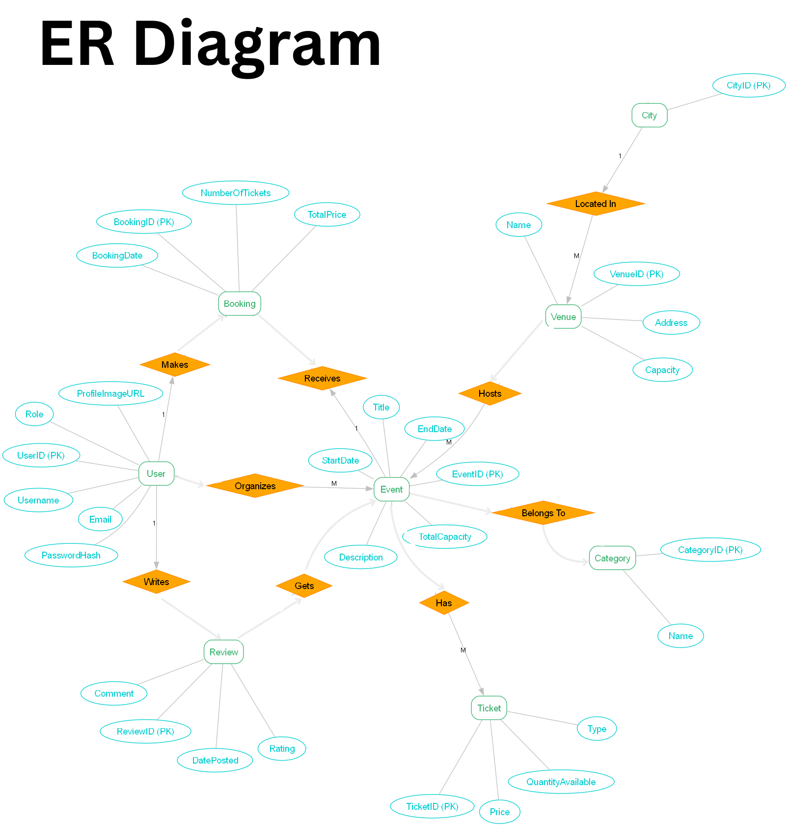**  
  
  
  
  
  
  
  
  
  
  
  
  
  
  
  
  
  
  
  
  
  
  
  
  
  
  
  
  
  
  
  
  
  
  
  
  
  
  
  
  
  
  
  
  
  
  
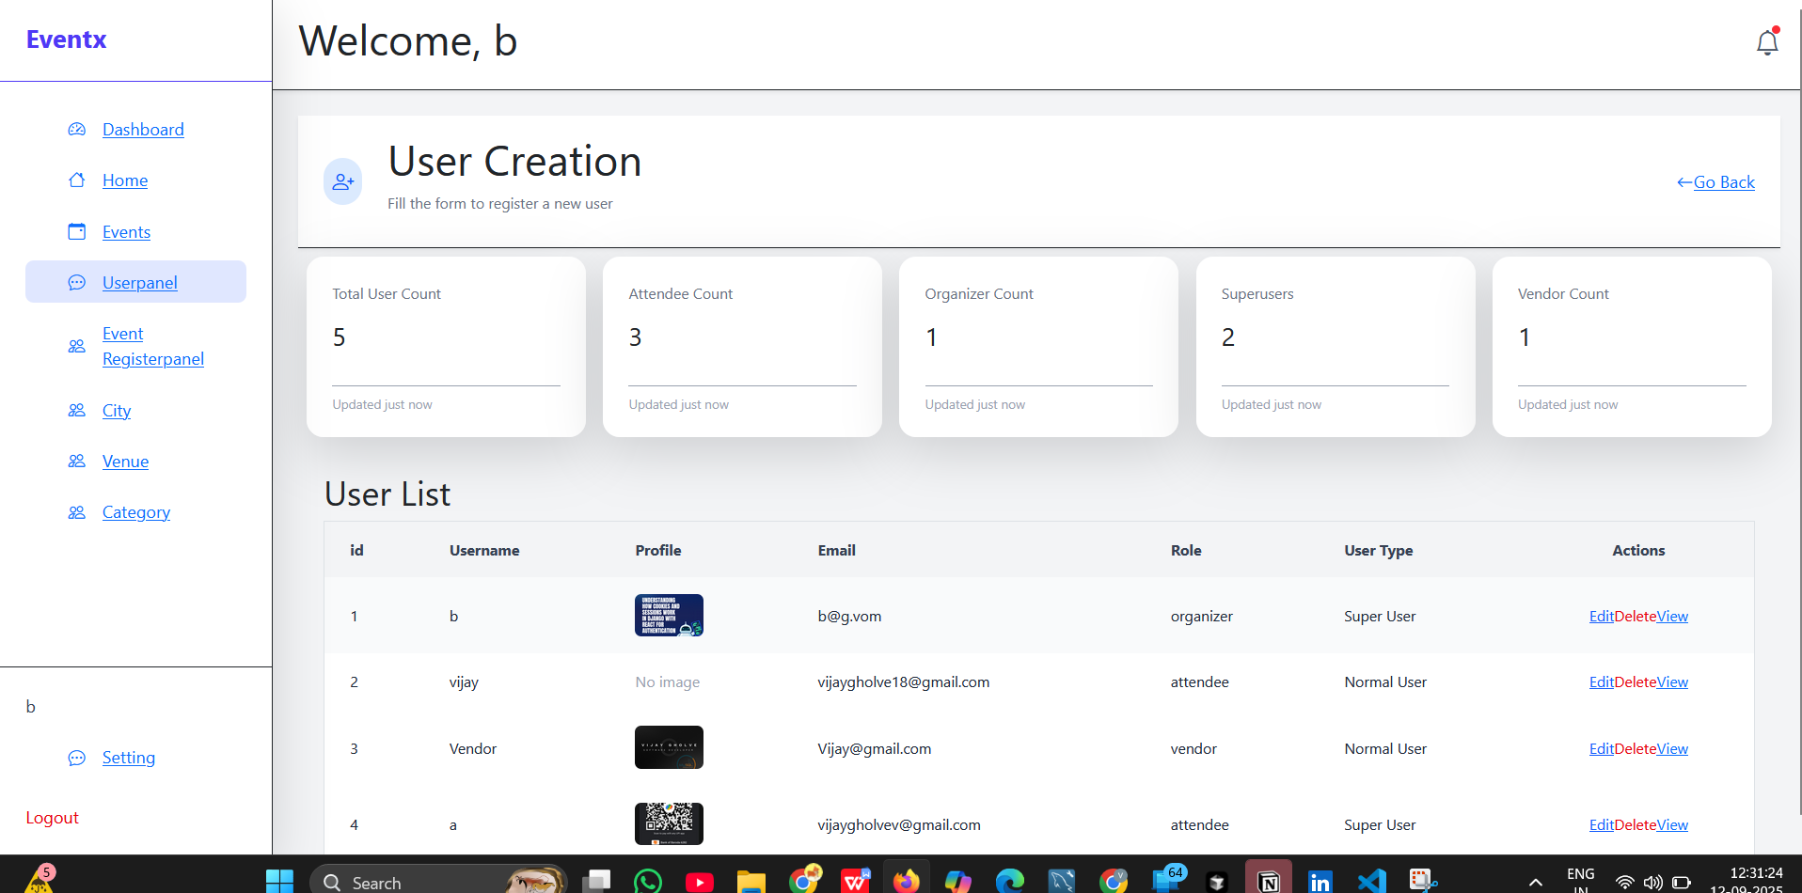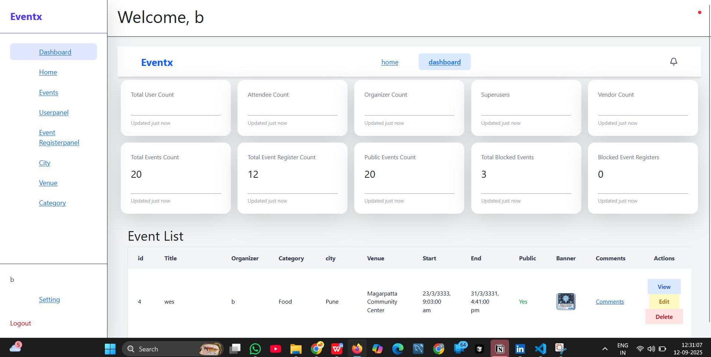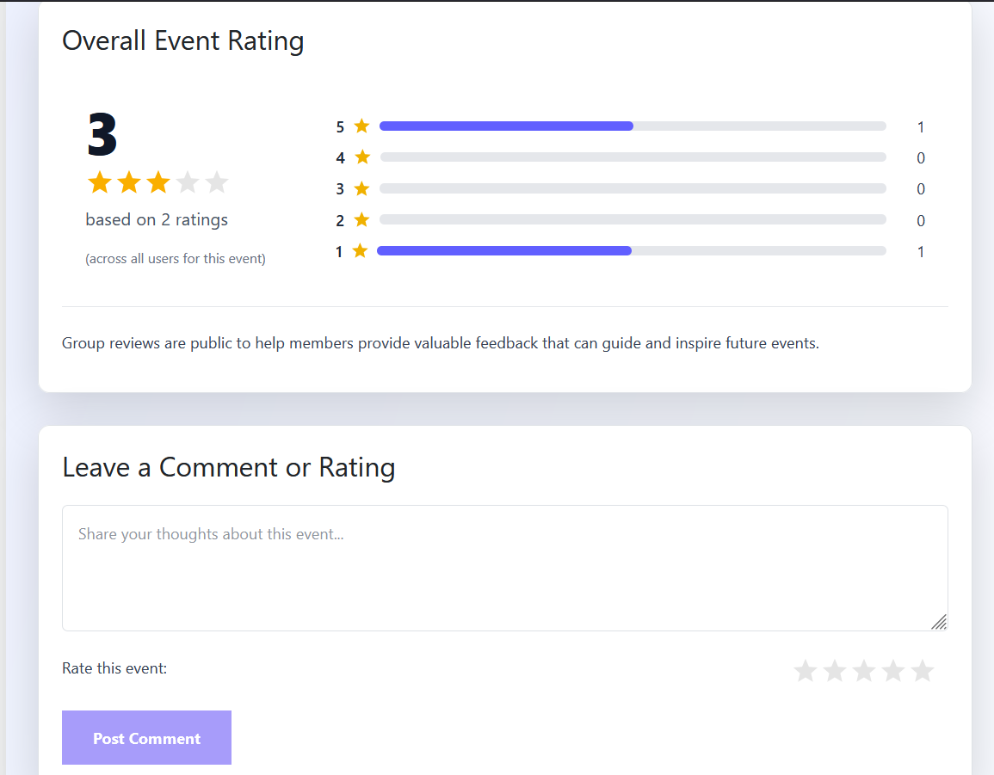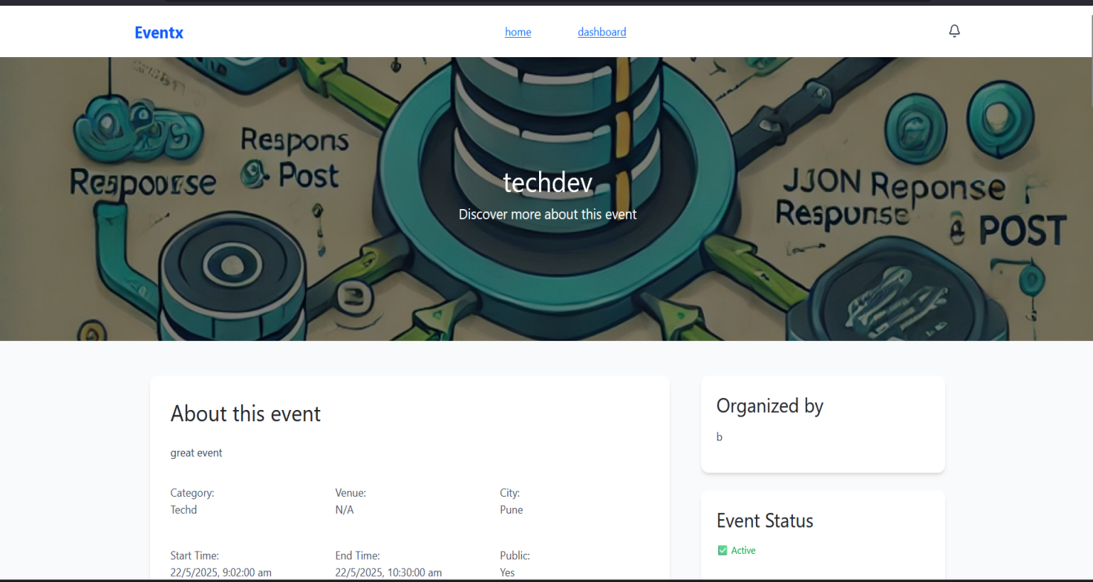

**Project Scope**

* Project Scope: ConnectLocal is scoped as a full-stack web application.
* User Management: Comprehensive user registration, profile creation, and
* authentication.
* Group Management: Functionality for creating, joining, leaving, and
* managing groups, including member roles and moderation tools.
* Event Management: Tools for scheduling, promoting, and managing events
* within groups, including RSVP tracking and attendance marking.
* Communication: Integrated messaging features for group members and
* event attendees, alongside discussion boards.
* Discovery: Advanced search, filtering, and basic recommendation capabilities
* for groups and events.
* Basic Analytics: Dashboards for group organizers to view key metrics on
* group activity and event attendance.
* Responsive Design: Optimized for seamless usage across desktop, tablet, and mobile devices

**Software/Hardware Specifications**

**Backend:**

* Language/Framework: Python 3.x with Django (latest stable version).
* API Framework: Django REST Framework.
* Database: PostgreSQL (for scalability and robust features).
* Authentication: Django's built-in authentication system with JWT for
* API token management.
* Image/File Handling: Pillow library for image processing.
* Real-time Communication: Django Channels (for WebSockets) or a
* dedicated messaging queue (e.g., Redis Pub/Sub).
* Deployment Environment: Cloud platform (e.g., AWS EC2/ECS, Google
* Cloud Run, Azure App Service) with containerization (Docker)

**Frontend:**

* Language/Library: JavaScript with React (latest stable version).
* Build Tool: Vite.
* Routing: React Router DOM.
* State Management: Redux Toolkit.
* HTTP Client: Axios.
* UI Framework/Libraries: Tailwind CSS for utility-first styling,
* potentially Material-UI or Ant Design for robust components, Framer
* Motion for animations, Lucide React for icons

### **Conclusion**

The development of **ConnectLocal: Community Meetup Platform** represents a strategic and comprehensive effort to address a significant gap in the digital landscape of social interaction. By providing a unified ecosystem for event discovery, streamlined organization, and genuine community engagement, this project is poised to deliver substantial value to its diverse stakeholders. The platform's scalable architecture, built on robust technologies such as Django and React, along with a strong focus on security and a user-centric design, ensures a reliable, high-performing, and intuitive experience. ConnectLocal's successful implementation will not only modernize the process of event management but also empower individuals to forge meaningful, real-world connections, thereby enriching local communities. The platform's design, guided by a thorough literature review and detailed system analysis, positions it as a forward-thinking solution capable of evolving to meet future market demands and technological advancements.

### **Bibliography and References**

**[1]** The Django Software Foundation. (2024). *Django Documentation*. Retrieved from [https://docs.djangoproject.com/](https://docs.djangoproject.com/" \t "_blank) (The official source for the core backend framework, essential for implementation details.)  
**[2]** Postman. (2024). *JWT Authentication Best Practices*. Retrieved from [https://www.postman.com/jwt-authentication/](https://www.google.com/search?q=https://www.postman.com/jwt-authentication/" \t "_blank) (A resource for understanding and implementing secure, token-based authentication protocols.

**[3]** The React Team. (2024). *React Documentation*. Retrieved from [https://react.dev/](https://react.dev/" \t "_blank) (The primary resource for the frontend library, including hooks and component-based architecture.)

**[4]** O'Reilly Media. (2023). *API Design Patterns: Microservices, CQRS, and Beyond*. (A reference for designing scalable and robust APIs using modern principles, which is critical for the Django REST Framework implementation.)

**[5]** Laux, A. (2022). *Data Modeling for Modern Applications: A Practical Guide*. Packt Publishing. (Informs the creation of the ERD and normalization of the database schema.)

**[6]** Shneiderman, B., Plaisant, C., & Cohen, M. (2020). *Designing the User Interface: Strategies for Effective Human-Computer Interaction*. Pearson. (Offers established best practices for designing intuitive and accessible user interfaces.)